Tour de Coop Press Release
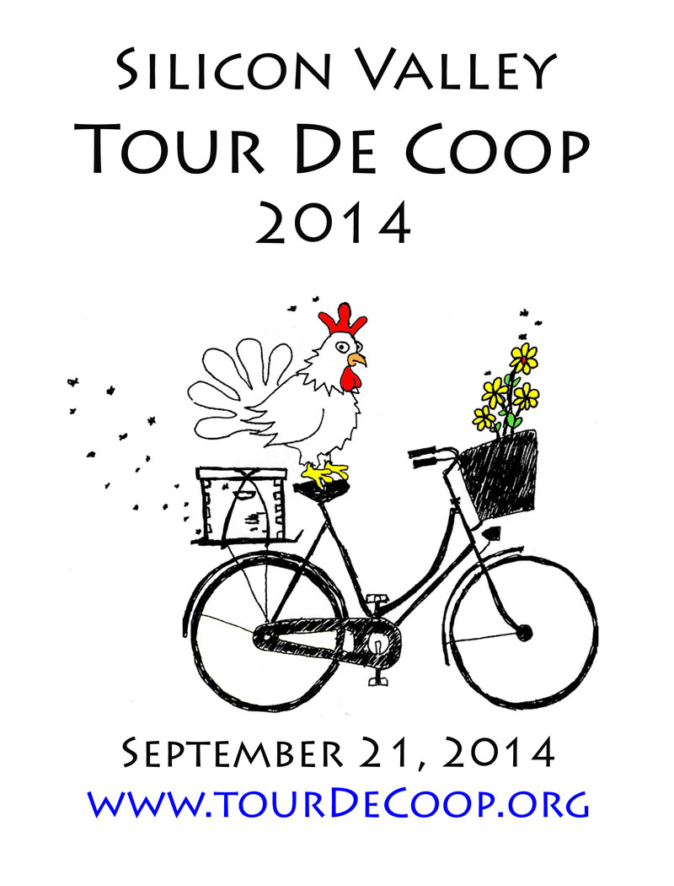

Press Release
Date: May 19, 2014
Primary Contact: Scott Vanderlip (scott@inet-sciences.com / 650-793-0475)
Event Date: Sunday, September 21, 2014 – 9 AM to 4 PM

For Immediate Release:

Title: Silicon Valley Tour de Coop 2013-- a self-guided bicycle tour of chicken coops and urban farms between Menlo Park and San Jose.

The second annual Silicon Valley Tour de Coop, bike ride and coop tour is taking place 9am - 4pm Sunday, September 21, 2014. This free, self-guided bicycle tour of chicken coops and backyard urban homesteads, including honey bees, worm composting, and organic gardening, and, of course, chickens coops. Experienced coopsters will show off their coop handiwork while sharing their joy of raising chickens and the benefits of creating backyard ecosystems that support the residents as well as the planet.

In addition to providing a fun, family friendly, community building event, the organizers also hope to energize those "on the fence" to jump into the urban homesteading movement. As Michael Pollan says in his book Food Rules: An Eater's Manual, "What we eat determines to a great extent the use we make of the world-- and what is to become of it." In a time when lists of ingredients are virtually unintelligible, raising chickens or bees, and gardening organically provides wholesome, fresh, nourishing food, as well as being a balm for the earth.

This year's tour features a variety of coop tour routes, with individual city loops (5-10 miles) and a larger 50 to 100 mile loop including stops from San Jose to Menlo Park and every city in between. Participants, or "tourists" register for a limited number of reservations on Eventbrite and a few days prior to the tour receive a printable map showing the tour route. Full details are available at the Coop Tour website, http://tourdecoop.org.

So grab your bike, your friends, and family and join us on the Silicon Valley Tour de Coop! Find out for yourself how to reconnect to the great outdoors of your own backyard. Enjoy meeting your neighbors and making new friends while cruising between coops on bikes!

For more information, contact Tour de Coop organizer Scott Vanderlip at scott@inet-sciences.com or at (650) 793-0475.

Attached: Graphic of Tour de Coop Poster & Photos

